Location: Parkshot
Reason for assessment: Reopening of site for learning – September 2020.
Name of Assessor (print name): Paul Smith (Executive Director responsible for Facilities) Date of Assessment: 4/9/2020 (last updated 09 10 20)

Hazards identified from the Work Activities being carried out by students and tutors - including the use of COSHH, Machines, equipment etc | Who is at risk/ affected? | List Existing Controls – are they adequate, is risk reduced as far as possible? | Like- lihood of accident  (1 – 5) | Severity  (1 – 5) | Overall  Risk  Rating =  (LxS=R) | Is Risk  Accept- able  Yes/No | State any immediate ACTIONs taken by assessor AND list further Controls and Actions to be taken and Prioritise |  | New risk  rating  LxS=R  (RR) | Where and Who each Action reported to for each new Control/ Action (e.g. HELP-desk + Ticket No., Line Manager, Tech.etc | Monitor new controls – if they are not effective. re-rate risk and REVIEW Risk Assessment
Risk of virus being brought onto Parkshot site. | All persons coming onto site could potentially bring virus onto site. | Government alert level has reduced from level 4 to level 3. Rate of transmission has reduced. | 2 | 3 | 6 | No | Public transport to be avoided if possible. This is included in guidance to staff/learners.  Staff, learners and visitors will be required to wear face coverings (unless exempt: For example, people who:  - cannot put on, wear or remove a face covering because of a physical or mental illness or impairment, or disability  - are speaking to or providing assistance to someone who relies on lip reading, clear sound or facial expression to communicate)  in communal areas or where 2 metre distance cannot be maintained. Tutors and front facing staff will be provided with visors.  Only staff required to come onto site to perform duties will travel to site.  Learners will sign a new learning agreement that includes a declaration that they do not have Covid-19 symptoms.  Signage being installed to advise all coming onto site: frequency handwashing/sanitising, avoid touching face, maintain social distance, go home and isolate if feeling unwell with Covid19 symptoms.  Staff and learners will be asked to use sanitizer or wash their hands on arrival at the site.  A record will be taken of the contact details all visitors/enquirers to site to enable the government’s Track and Trace system to be utilised in the event of an outbreak.  NHS App posters will be displayed at all entrances enabling learners to check in to site.  All people entering the site will be directed to the reception door so that track and trace details can be taken of visitors and enquirers, and early learners directed to wait outside..  Markers encouraging social distance installed. |  | 3 | HR Director and ED, Commercial. | Continued review of Government guidance.
Risk of virus being spread on site. | All persons on site. | Cleaning service in place. | 2 | 3 | 6 | N | Enhanced cleaning service implemented. Including: frequent clean of high touch hard surfaces, cleaning throughout the day, enhanced antiviral products, all work stations cleaned 1/day. Note also – Estates and Facilities Manager will coordinate with Cleaning team on daily basis to check/co—ordinate cleaning, in part based on classrooms used that day.  Social distancing to be observed. Included in signage and instructions to those coming on site.  Windows/doors (NOT fire doors) to be kept open to increase ventilation where possible.  Each classroom will be assessed to determine safe number of learners/tutors per room based on social distancing of 2m. Enrolments will be capped based on this max. capacity.  If a learner is taken ill on site with Covid-19 symptoms, or receives an NHS App notification that they have been in contact with a positive Covid-19 case, the classroom and any facilities the learner uses (e.g. toilets, first aid room) before going home will be deep cleaned.  Staff, learners and visitors will be required to wear face coverings (unless exempt) in communal areas or where 2-metre distance cannot be maintained. Tutors and front facing staff will be provided with visors. |  | 4 | Estates and Facilities Manager. | Continued monitoring of government guidance. Ongoing monitoring of cleaning, signage, flow by ED. Commercial.
Risk of transmission in high use part of site.  - Common areas  - Toilets  - Workstations  - Printers  - Desks  - Kitchens  Notes – see separate risk analysis for classrooms. | All persons on site. | Cleaning service in place across site. | 2 | 3 | 6 | N | Additional controls:  Increase cleaning – see above.  Single use of kitchens only. Signage to be placed in kitchens advising need to clean pre and post use. Cleaning products will be provided. This is in addition to usual cleaning service (also enhanced).  Increased cleaning of toilets. Signage in toilets reminding users to wash hands for 20 seconds.  Signage, cleaning products and bins to be provided at printers.  Cleaning products to be provided for keyboards for self clean – per and post use by learner/staff member. Bins will be reintroduced into classrooms and offices to allow for the safe disposal of wipes.  Furniture will be reduced in common areas – e.g. tables and chairs. Some furniture will be marked as unusable (hazard tape).  Staff, learners and visitors will be required to wear face coverings (unless exempt) in communal areas or where 2 meter distance cannot be maintained. Tutors and front facing staff will be provided with visors. |  | 3 | Estates and Facilities Manager | Continued monitoring of government guidance. Ongoing monitoring of cleaning, signage, flow by ED. Commercial.
Risk of Covid19 transmission at Café. | All on site | No specific controls | 2 | 3 | 6 | N | The café is open with limited provision. Learners should take purchased refreshments either off site or into their classroom.  There will be no communal dispensing of items such as milk, which will be added by Educated Palate staff.  Educated Palate risk assessment will be reviewed regularly. |  | N/A |  | N/A
Use of the Lift | All on site. | There are no existing controls in place. | 2 | 2 | 4 | Y | Instruct that only one person may use the lift at any one time, with exception of situation where leaner requires support. In which case max. is 2 and individuals should face away from one another whilst in lift.  Staff, learners and visitors will be required to wear face coverings (unless exempt) in communal areas or where 2- metre distance cannot be maintained. Tutors and front facing staff will be provided with visors.  More regular cleaning of buttons/handles |  |  | Estates and Facilities Manager | Continued monitoring of government guidance. Ongoing monitoring of cleaning, signage, flow by ED. Commercial.
Fire evacuation procedure does not require for social distancing. | All on site | Fire evacuation procedures in place and tested on termly basis. | 1 | 5 | 5 | N | Evacuation procedures will remain in place, with staff and learners assembling at the muster point in the Old Deer Car Park.  Social distancing to be maintained and face coverings to be worn (unless exempt). Fire Marshals at the muster point to remind staff and learners of these measures.  Site visitors/contractors will assemble at the muster point to be checked off against the sign-in register.  (Chief Fire Marshal:  Parkshot – Destiny Belle or member of caretaking team in her absence.) |  | 4 | Estates and Facilities Manager | Evacuation procedures to be reviewed after three weeks (28 September)  Continued monitoring of government guidance. Ongoing monitoring of cleaning, signage, flow by ED. Commercial.
Current first aid protocols include risk of covid19 transmission. | First aiders and anyone requiring first aid. | No specific additional controls in place. | 2 | 3 | 6 | N | Protective equipment to be provided to first aiders. Including surgical grade face coverings, visors, gloves, aprons.  Instructions to be provided to first aiders on how to deal with first aid incidents during the pandemic. PPE to be used.  Risk of no first aider on site to be managed via schedule of staff on site that have first aid training. Rota to be created. |  | 4 | HR Director | HR Director to monitor process. In conjunction with
Risk of visitors and contractors bringing virus onto site. | Reception | There are no existing controls in place. | 2 | 3 | 6 | N | See controls above (first item in table)  The College is only open to visitors by appointment  and may be limited to contractors carrying out essential works at specific times.  Reception to sign in / out any visitors or enquirers and take track and trace details (with sanitiser station located at sign in point).  Social distancing required for all visitors (signage in place).  Signage to include instructions for social distancing, sanitising etc whilst on site.  Staff, learners and visitors will be required to wear face coverings (unless exempt) in communal areas or where 2-metre distance cannot be maintained. Tutors and front facing staff will be provided with visors. |  | 4 | Estates and Facilities Manager | Continued monitoring of government guidance. Ongoing monitoring of cleaning, signage, flow by ED. Commercial.
Links to other risk assessments linked to Covid-19 pandemic. |  | The following risk assessments have been prepared for specific groups:  - Hillcroft site  - Bridge Workspace  - Events and Hires  - Vulnerable learners  - Staff returning to site  - Classroom activities  - Creche | N/A | N/A | N/A | N/A | N/A |  | N/A | N/A | N/A
Assessment approved by (eg Line Manager) : | 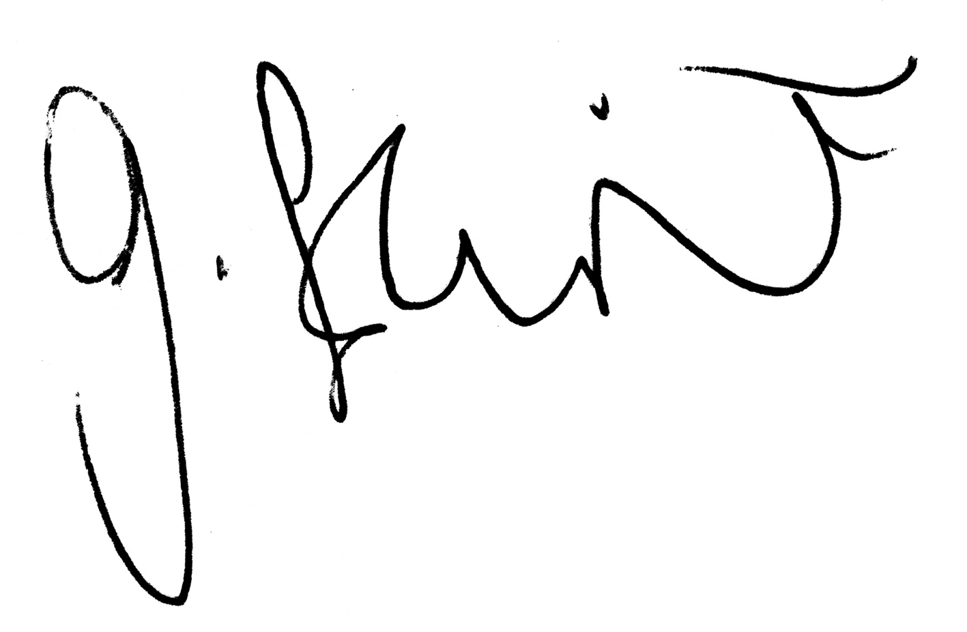  Who: Gabrielle Flint  When: 04 09 2020 |  |  |  |  | Proposed Review – state date and/or Review Conditions |  | 24 September 2020

Review
Date of Review and Findings:  24 September 2020 | Minor edits made to reflect the latest government guidance. | Assessor signature:  Paul Smith
02 December 2020

RISK RATING
L = Likelihood | (5)-Frequent; (4)-Probable; (3)-Occasional; (2)-Remote; (1)-Improbable
S = Severity | (5)-Fatal; (4)-Major; (3)-Serious; (2)-Minor; (1)-Low
R = Risk Rating | (LxS)-Likelihood x Severity
RR = Residual Risk Rating | Risk Rating following application of Additional Controls: 15 to 25 – Unacceptable and/or 10 to 14 – High (Remove hazard or consider re-deployment immediately); 6 to 9 – Medium (Adapt working practices and review in 2–4 weeks); 4 to 5 – Low (Review in 4–8 weeks); 1 to 3 – Negligible.

COMMENTS AND INFORMATION
Use this section to record how the risk assessment & control measures have been communicated, and any other comments and information
This Risk Assessment will be displayed on the wall of the classroom, and sent to each learner prior to attending a classroom-based course during Summer School 2020. Tutors to draw attention to the Risk Assessment at beginning of first session. By signing the learning agreement, learners are accepting the control measures in this risk assessment, and are agreeing to comply. Any learners who do not follow the control measures in the assessment will be asked to leave.

https://www.gov.uk/government/publications/coronavirus-covid-19-implementing-protective-measures-in-education-and-childcare-settings/coronavirus-covid-19-implementing-protective-measures-in-education-and-childcare-settings

Attendance at College
https://www.nhs.uk/conditions/coronavirus-covid-19/people-at-higher-risk-from-coronavirus/whos-at-higher-risk-from-coronavirus/

https://www.gov.uk/government/publications/coronavirus-covid-19-implementing-protective-measures-in-education-and-childcare-settings/coronavirus-covid-19-implementing-protective-measures-in-education-and-childcare-settings#shielded-and-clinically-vulnerable-children-and-young-people

https://www.gov.uk/government/publications/covid-19-stay-at-home-guidance/stay-at-home-guidance-for-people-with-confirmed-or-possible-coronavirus-covid-19-infection

Returning to work/college
https://www.nhs.uk/conditions/coronavirus-covid-19/people-at-higher-risk/whos-at-higher-risk-from-coronavirus/

Hand hygiene
https://new.brighton-hove.gov.uk/sites/default/files/campaigns/Coronavirus/Coronavirus%20handwashing%20landscape%20and%20portrait%20A4%20Poster.pdf

Cleaning
https://www.gov.uk/government/publications/covid-19-decontamination-in-non-healthcare-settings/covid-19-decontamination-in-non-healthcare-settings

Windows in corridors and ventilation
https://www.rehva.eu/fileadmin/user_upload/REHVA_COVID-19_guidance_document_ver2_20200403_1.pdf

Stay at home guidance
https://www.gov.uk/government/publications/covid-19-stay-at-home-guidance

Controls declaration poster
https://assets.publishing.service.gov.uk/media/5eb97d30d3bf7f5d364bfbb6/staying-covid-19-secure.pdf

All classroom risk assessments shared with all staff via Sharepoint, and all-staff emails.

